Conclusions

1. Theater category gets more backers as compared to any other category, but journalism has 100% success rate.
2. Based on data there are 565 successful projects from 1000 project samples. So, chances project getting successful is more than project failing or getting canceled.
3. Projects which have goal between 15000-24999 and 30000 to 34999 ha 100% success rate.

Limitations

1. There are four distinct types of crowdfunding charitable (donation), equity-based, reward based, and loan based. But our sheet does not specify type of crowdfunding.
2. Categories Food, journalism, photography, theater have only one subcategory food truck, audio, photography books, plays respectively. So, need more dataset on these categories.

Other possible table

We can create table to display number of categories get funded each year

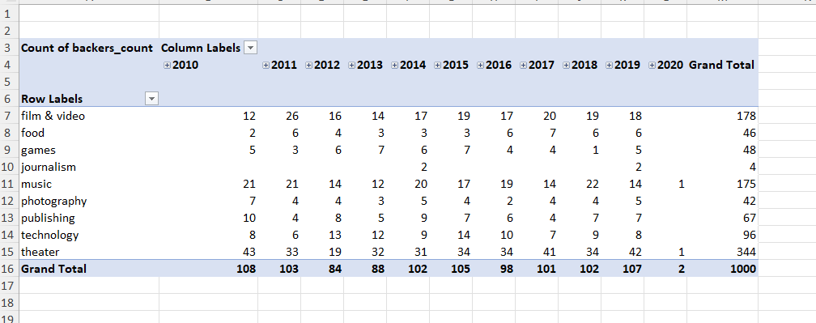

Statistical Analysis

* Mean is higher than median in both successful and failed projects. Mean summarizes data best in both cases as we see maximum is much higher.
* Successful data set is bigger as compared to failed projects. Also, there is more difference in minimum and maximum. Due to that there is more variability in successful data set.